# Artificial Neural Networks in Sleep Stage Prediction Model

## Phase – 1

### Architecture

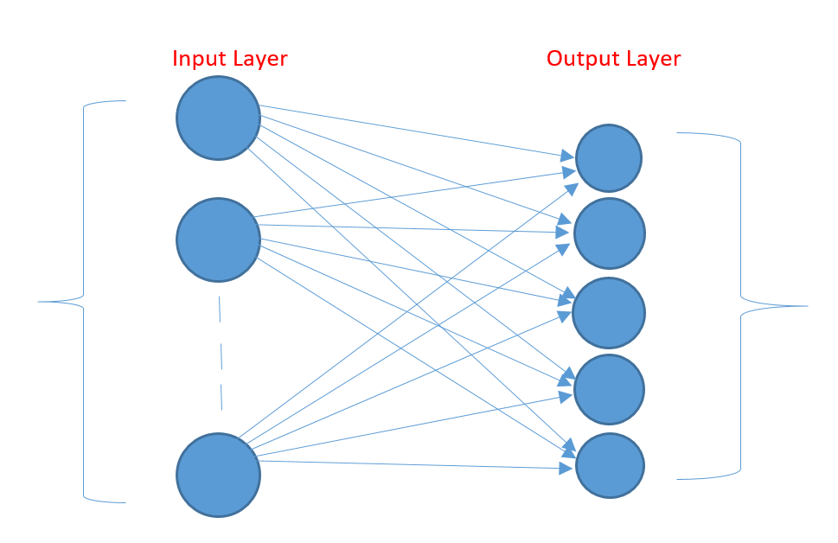 Activation – ReLU Activation – Softmax

Input layer – 28 neurons

Output layer – 5 neurons

### Classification Report

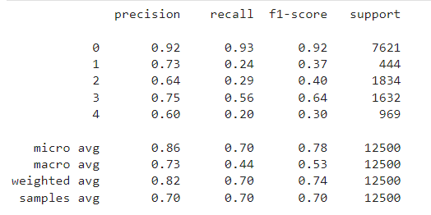

## Phase – 2

### Architecture



Activation – ReLU Activation – Softmax

Input Layer – 42 neurons

Output Layer – 5 neurons

### Classification Report

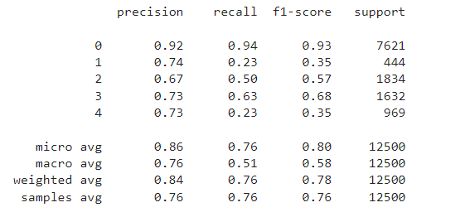

## Phase – 3

### Architecture



Activation – ReLU Activation – Softmax

Input Layer – 210 neurons

Output Layer – 5 neurons

### Classification Report

